**Tutorial 6 FAQ**

* **What is "stride" ?**

We can treat our filter as a window sliding in the input matrix, then "stride" means how many step our window will slide.

1. 3 x 3 kernel with stride 1

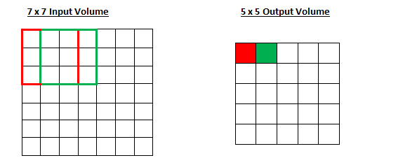

1. 3 x 3 kernel with stride 2

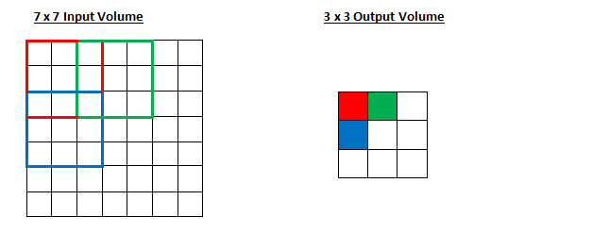

* **Where can I find more details about CNN ?**

<http://cs231n.github.io/convolutional-networks/>